FB2020 Assembly

Frame Assembly

Pre-Assembly T Nuts
Pre-Assembly T Nuts are just that, they need to be added to the part before assembly like so:
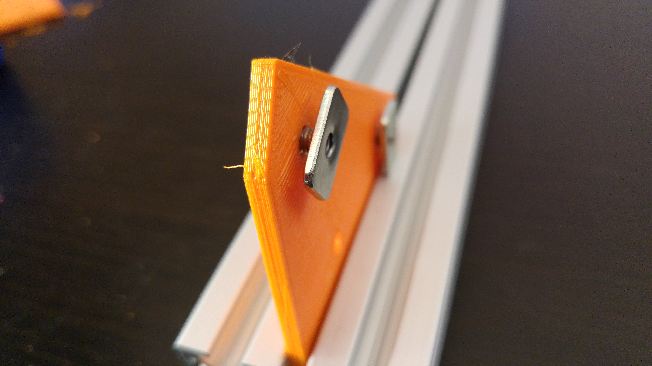
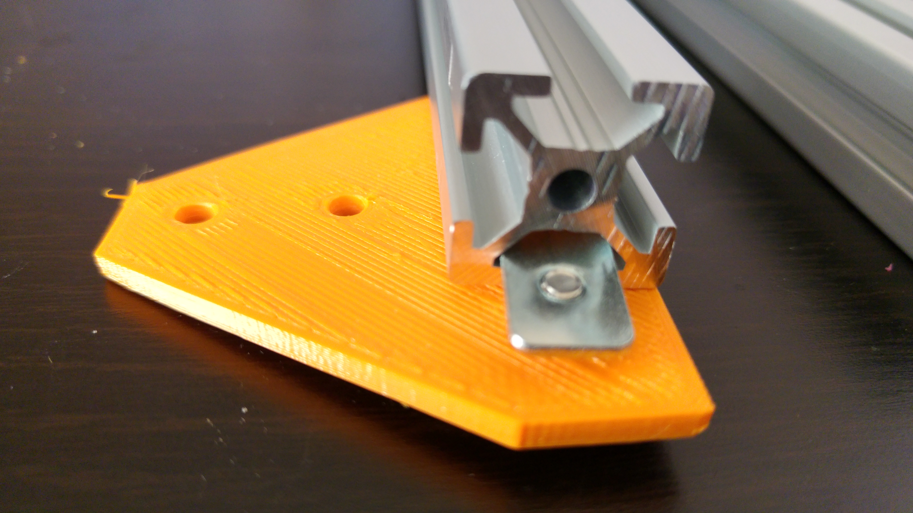
The part can then be slid into the extrusion and tightened:
All structural parts require the pre-assembly type of T Nut and 8mm M4 Bolts.

Frame – Front
Take the 2 of the 345mm (standard) or 2 of the 445mm extrusions and slide the 2 of 4 bottom corner brackets in and tighten, one per extrusion so they mirror each other:
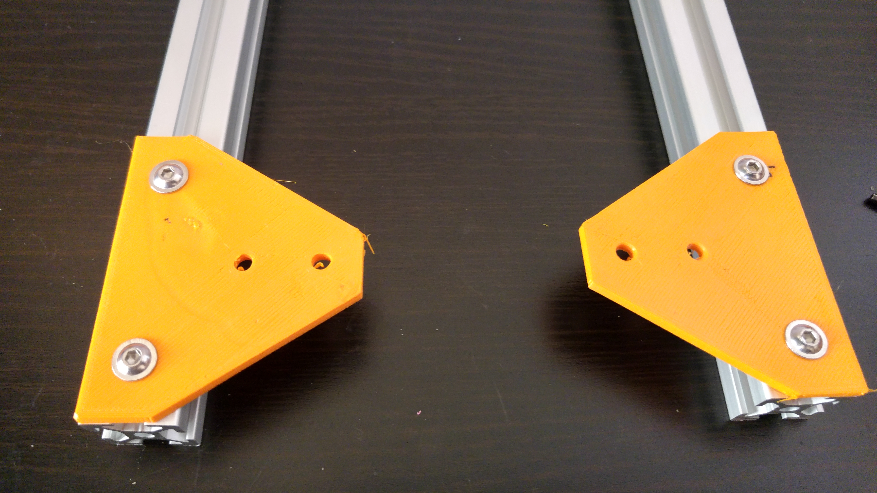
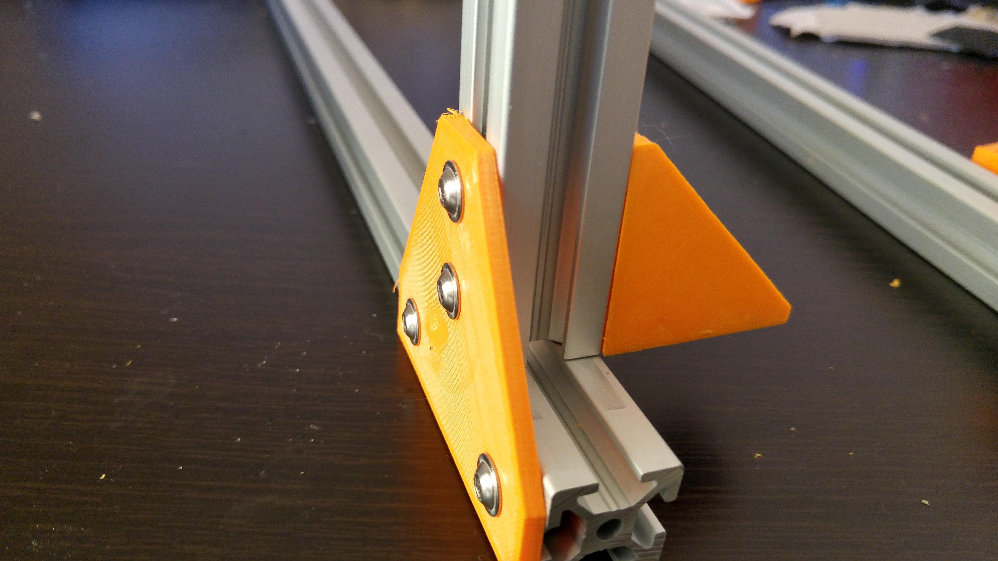
Take a 380mm extrusion and then place 2 corner brackets at each end, once again, mirroring each other. Slide one end of the 380mm extrusion into the bottom corner bracket with the corner bracket on the opposite side, making sure the extrusion butts up against the vertical one tightly, tighten the bolts:
Repeat this for the opposite end. You should now have a U shape.

Z Axis

Bearing insertion
Method 1 – Threaded Rod (Easiest)
Use 8mm threaded rod with 2 nuts & washers. Like so:
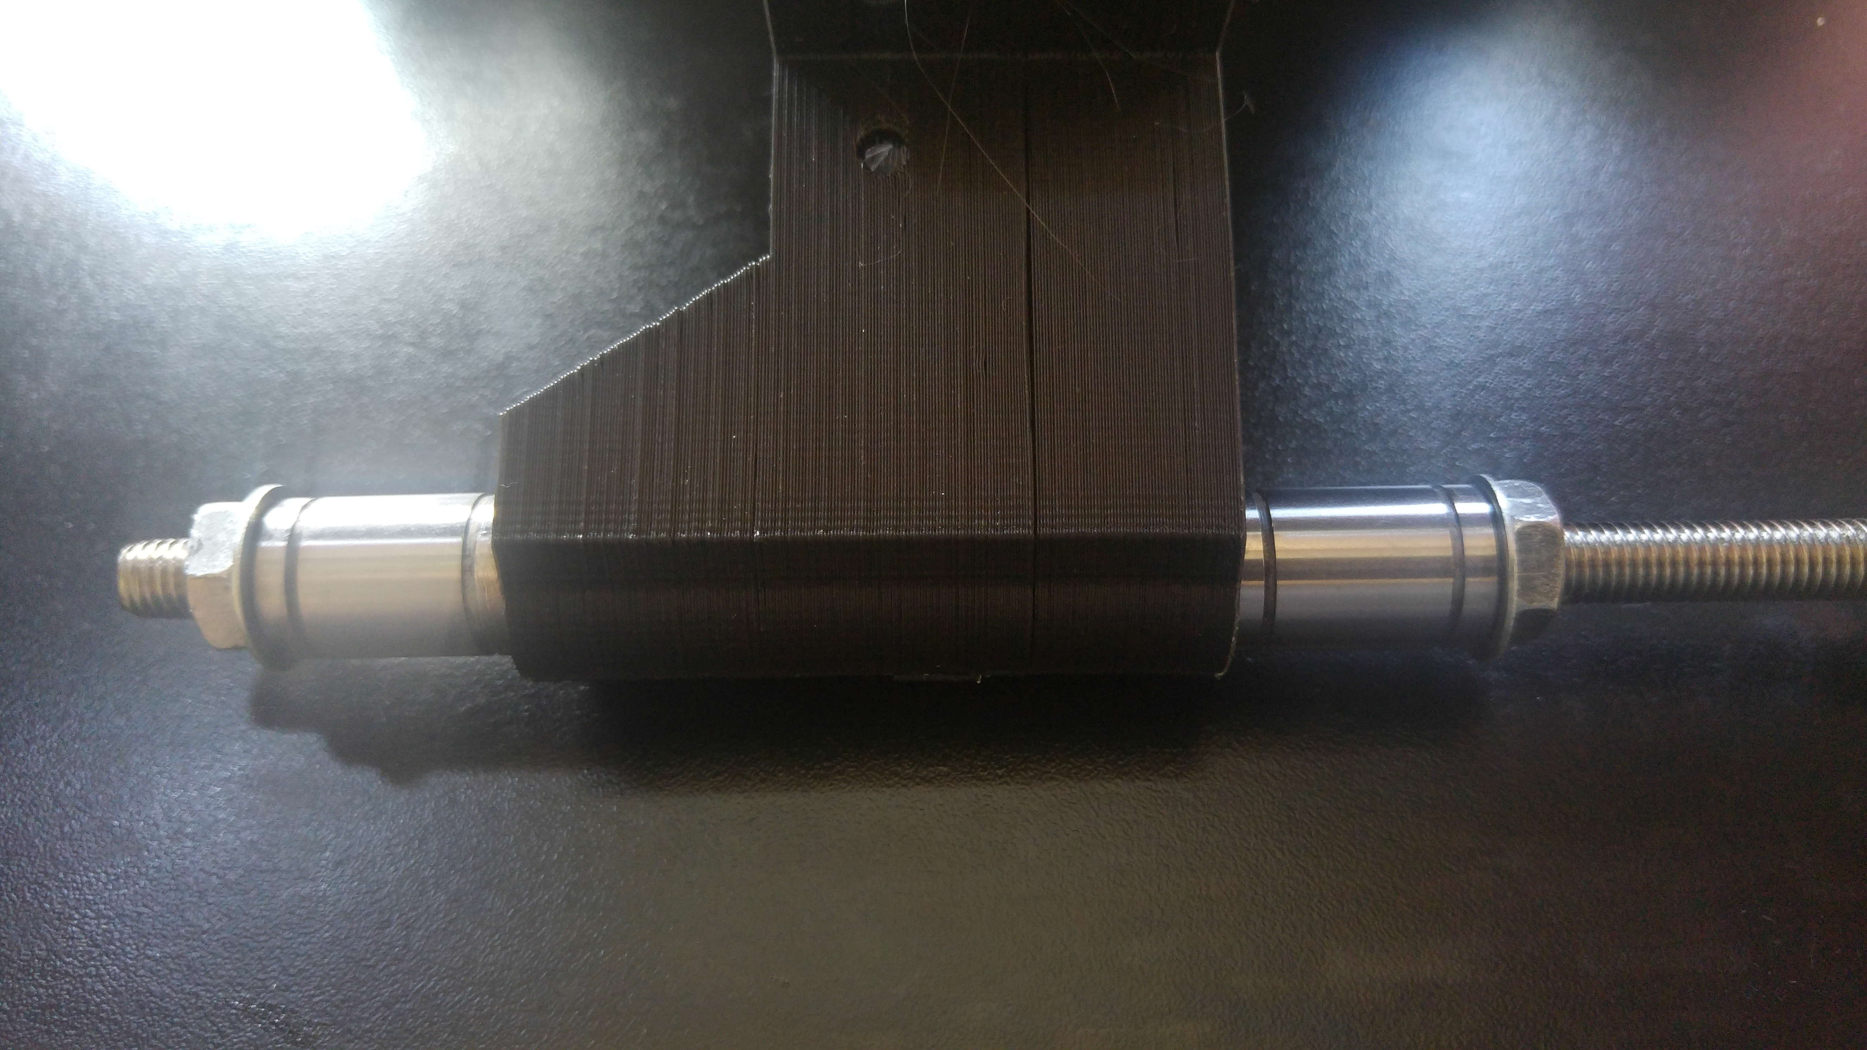
Tighten one nut slowly to make sure no de-lamination of the part occurs. This will pull both bearings into the part. Take off one nut and washer and screw the nut back on so it's flat with the bearing. Tighten the side with the washer so it pulls the side without the washer into the part about quarter to half way down the nut. Release the side with the washer and push the bar up freeing up the nut, unscrew and repeat on the other side. This is done to avoid any lips from the print process.

Method 2 – Use the Z smooth rod holder
Place the Z rod holder on the end of the smooth rod like so:
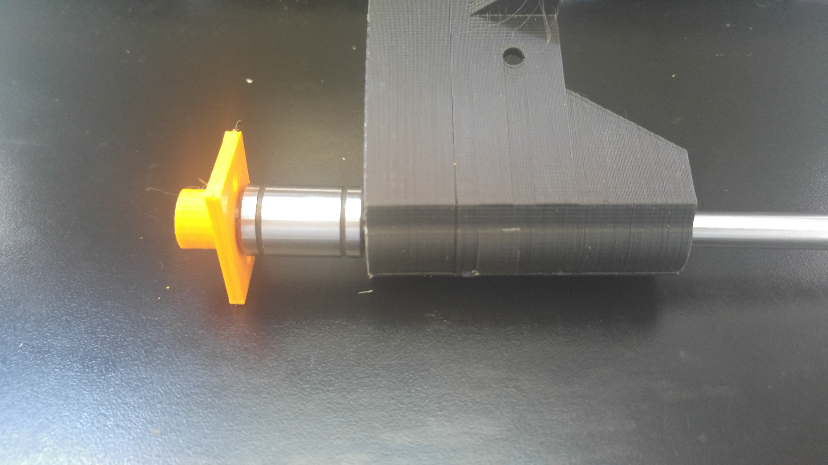
Hold the Rod vertically and apply pressure to the bed carrier. This will likely need a lot of pressure but take your time so to not damage the part. Flip the part and repeat with the second bearing.

Next take a smooth rod and make sure the part slides freely. You should be able to hold the rod vertically and the part should drop to your hand without binding. If not, pull the rod out to where there's a small length over the top of the bottom bearing inside the part. Gently push the rod towards the extrusion mounting, holding the rod near the part to avoid bending the rod, there should be a little movement. Test it again, if it's become worse, repeat the same but pushing the rod in the opposite direction. If it's become better but still doesn't slide freely, repeat the above again until it slides freely.

